Supervision, training incumbents and curates
Training Incumbent – or Supervising Minister?
PASTORAL SUPERVISION IS:
- a regular, planned, intentional and boundaried space in which a practitioner skilled in supervision (the supervisor) meets with one or more other practitioners (the supervisees) to look together at the supervisees’ practice
- a relationship characterised by trust, respect, confidentiality, support and openness that gives the supervisee freedom and safety to explore the issues arising in their work
- spiritually/theologically informed – works within a framework of spiritual/theological understanding in dialogue with the supervisee’s world view and role
- psychologically informed – draws on relevant psychological theory and insight to illuminate intra-personal and inter-personal dynamics
- contextually sensitive– pays attention to the particularities of setting, culture and world-view
- praxis based– focuses on a report of work and /or issues that arise in and from the supervisee’s practice
- a way of growing in vocational identity, role competence, self-awareness, spiritual/theological reflection, quality of presence, accountability, response to challenge, mutual learning
- attentive to issues of fitness to practice, skill development, management of boundaries, professional identity and the impact of the work upon all concerned parties.
Association of Pastoral Supervision & Education – www.pastoralsupervision.org.uk

The specifics of the Curate/TI relationship
Multiple roles – including assessment and evaluation
An uneven power dynamic
Balancing encouragement and assessment, reflection, development and authority
What’s involved?
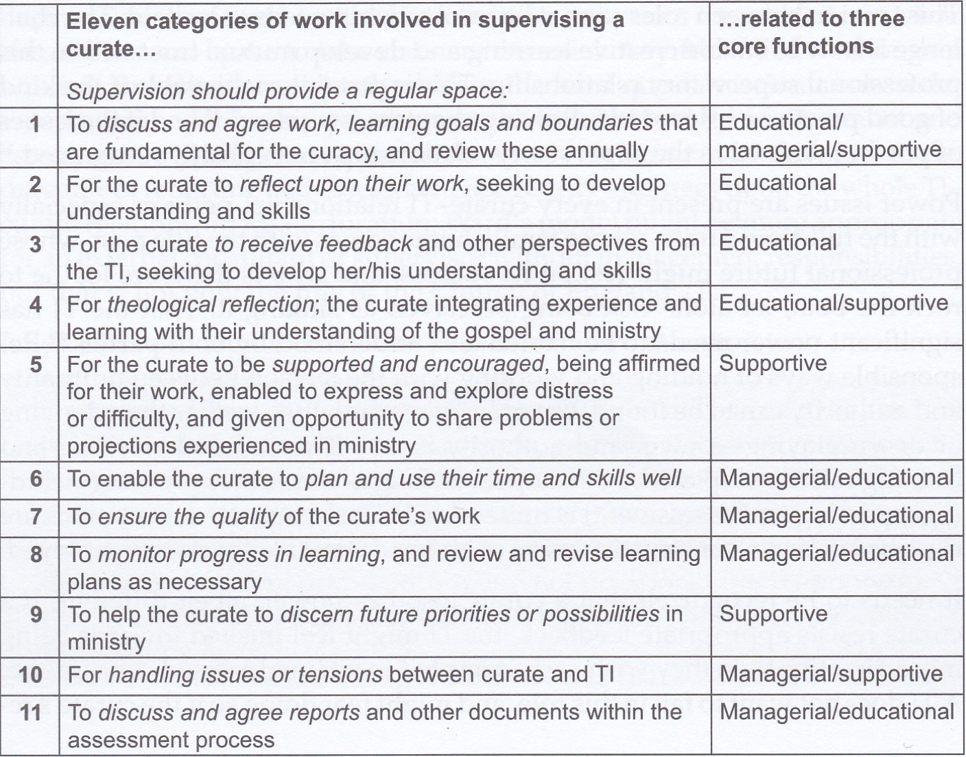

Giving of :-
- Time
- Feedback
- Self - being unthreatened

Coaching, mentoring and more
What it is and what it isn’t
Boundaries and other avenues

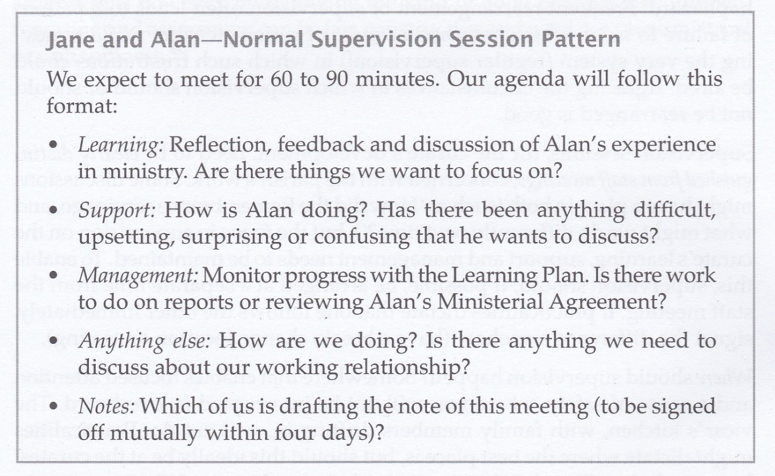
Meeting up – how often and how?

Keep talking to us…

Scans taken from
- Rick Simpson, Supervising a Curate – Grove P128 (out of print)
Other resources:-
- Helen Dixon Cameron Living in the Gaze of God: Supervision and Ministerial Flourishing
- Jon J Marlow Thriving in Curacy – Grove L42
- Keith Lamdin & David Tilley Supporting New Ministers in the Local Church
- Jane Leach & Michael Patterson Pastoral Supervision – A Handbook
- 3D Coaching’s Youtube channel
There are various resources on John Truscott’s website that are relevant, but one potentially helpful one is the one on working with a “number 2” (even if it does start by explicitly saying this is NOT the same as having a curate, which is a training situation). TN101 Working with a No. 2 / Training Notes index / Resources / Welcome! - John Truscott (john-truscott.co.uk)

From Herbert & Nash Supervising Youth Workers (Grove P105, 2006)

ESTABLISHING A SUPERVISION CONTRACT
It can be helpful to devise a contract for supervision, so that both parties are working to the same understanding and expectations.
- Purpose
Identify management, education, support and mediation issues for the specific context. (A fuller outline of the importance and meaning of these terms for supervision is found in chapter 5 of this Grove booklet)
- Confidentiality
Trust is important, but need to bear in mind accountability. Good practice suggests that confidentiality is never broken without informing the supervisee.
- Boundaries
What can or cannot be discussed in sessions?
- Timing
How frequently does supervision happen? How long are the sessions?
- Place
Where is it appropriate to hold supervision?
- Cancellation
Supervision should have a very high priority. Cancellations should only happen rarely and the session should normally be rearranged.
- Preparation
What preparation will each party make? Does anyone need any information in advance, if so, how much in advance?
- Format
What shape will the supervision session take?
- Recording
Who will take notes of decisions made in supervision? Who will keep them? When/how will they be shared? Where are they stored?
- Review
When and how frequently will supervision be reviewed?

A POSSIBLE AGENDA FOR SUPERVISION SESSIONS
- How are things generally?
Open question to help both parties get into the session.
- Looking at the work
Share information, identify problems, plan ahead
- Specific issues
Either party may have specific issues they wish to discuss
- Relationships
Are there any relationship issues that need addressing?
- Priorities
What are the priorities for the next period of time?
- Training
Have any training needs been identified?
- Anything not covered elsewhere in the session
Opportunity for either side to raise something they need to
- Recording
Agree and note action points and priorities
- Next meeting
Arrange or confirm next meeting

