|  |  |
| --- | --- |
| May be an image of 2 people, dais, the Basilica of the National Shrine of the Immaculate Conception and text | Church House  5500 Daresbury Park  Daresbury  Warrington  WA4 4GE  T: 01928 718834  Date: 11 December 2024 |

*(Ian Scott-Dunn pictured right with incoming Chair, David Hermitt)*

**A PERSONAL MESSAGE FROM IAN SCOTT-DUNN, RETIRING CHAIR**

Moving on from the role that I’ve held for the past 9 years has been an opportunity to reflect on how the financial fortunes of our Diocese have fared. It’s been a great privilege to serve in this way and to help to both guide and communicate the finances. I’ve enjoyed working alongside our Bishops, the previous Diocesan Secretary George Colville, the central Finance Team.

I’ve also chaired the Finance and Scrutiny Committee (recently renamed Central Services Committee), a group made up of both laity and clergy elected and appointed to have oversight and critical observation of the processed and decisions around financial matters.

The people of Chester Diocese, in parishes from north to south, east to west have always been incredibly supportive and generous. Without your support in paying the Parish Share our clergy numbers would plummet, and our central support team shrink. Times haven’t been easy in recent years and our usual collection rate of 95% has fallen to 87% and may even be at 85% by the end of 2024. Each percentage point equates to £130,000 – roughly the equivalent of two clergy posts. The DBF has had to set a deficit budget this year of £946,000. While we are very careful to balance the books and reduce expenditure without compromising clergy numbers, the shortfall in our income can only be covered by reserves for a very few years before they run out. Without a rise in Parish Share collection the deficit will only get worse. I know that this situation is mirrored in many of your parish finances, with rising bills and shrinking reserves.

Contd/….

…/contd.

I realise that I’m painting a worrying picture of the future, but we mustn’t be without hope. My prayer is that we all hold this situation before God, putting our trust in Him for our future. If we are faithful to a vision of the future in which our priority is to share the Gospel with the 1.5 million who don’t yet know Jesus, I believe that He will be faithful to us.

However, we will all need to redouble our efforts at every level to make sure that collectively we are doing all we can to enable the mission and ministry of our amazing Diocese, made up as it is of faithful Christians in diverse parishes throughout Cheshire.

As I hand over to my successor David Hermitt, I want to add my thanks to every parish for their generosity and faithfulness and for the extraordinary efforts that they have made to pay the Parish Share. I wish David every blessing in his new role as he steers the DBF into the future. I trust that he will find it as rewarding to serve Chester Diocese as I have.

Yours sincerely

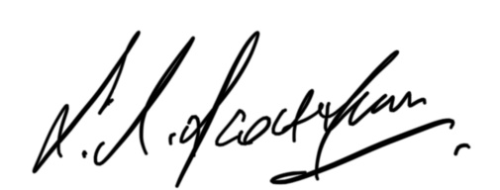

Ian Scott-Dunn

Retiring Chair, Chester Diocesan Board of Finance