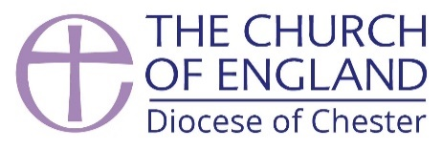
Clergy Discretionary Fund Application

Brief guidance notes are included overleaf. Please read these before completing this form, which should be returned to ministry@chester.anglican.org

Name
Phone number

Email address

Present appointment (including parish no.)

Date of application

Course/project for which a grant is requested (please give full details and dates):

What are your reasons for wanting to do this course / project?

What do you consider would be the benefits to the wider church / diocese / deanery / parish and to yourself of your participation in this course / project?

Full cost of course/project:

Amount you might hope to receive from the Discretionary grant

Please give details of any other sources of funding being claimed

Clergy Discretionary Fund
Guidance Notes

There is a limited discretionary fund available for licensed clergy. The fund is administered by the Ministry team and applications are considered by a panel that meets once each term.

In 2025, the deadlines for applications and panel dates are as follows:

Monday, 31st January for the panel meeting on Tuesday, 4th February
Wednesday, 30th April for the panel meeting on Tuesday, 8th May
Tuesday, 30th September for the panel meeting on Tuesday, 6th October

This fund is principally for licensed clergy engaging in a course of structured training or study, with fees or costs above those that could be covered by the standard CMD grant.

There are three application points in the year and if there are multiple applications there may be a competitive process. The panel will take into consideration the benefits of the proposed course of study to the diocese, the parish or ministry context, the wider church, and the individual.

The panel may choose to impose conditions on the award, for example an expectation that the individual is able to contribute to an aspect of wider ministry because of the resource they received.

Those awarded a grant will usually be asked to provide the panel with a written update on their progress after 6 months. Subsequent applications will be conditional on satisfactory progress being made in the initial course of study.

If demand is high, then applications may not be successful, and will be assessed on the deemed benefit of the proposed training or study, with preference also being given to the newest or first-time applicants.

Individuals will be notified of the outcome of the panel’s decision via email from a member of the Ministry Team, within three working days of the date of the panel.

Please return completed forms to ministry@chester.anglican.org. A member of the team will acknowledge receipt; if you do not receive this within three working days, please contact us to ensure your application was received.

