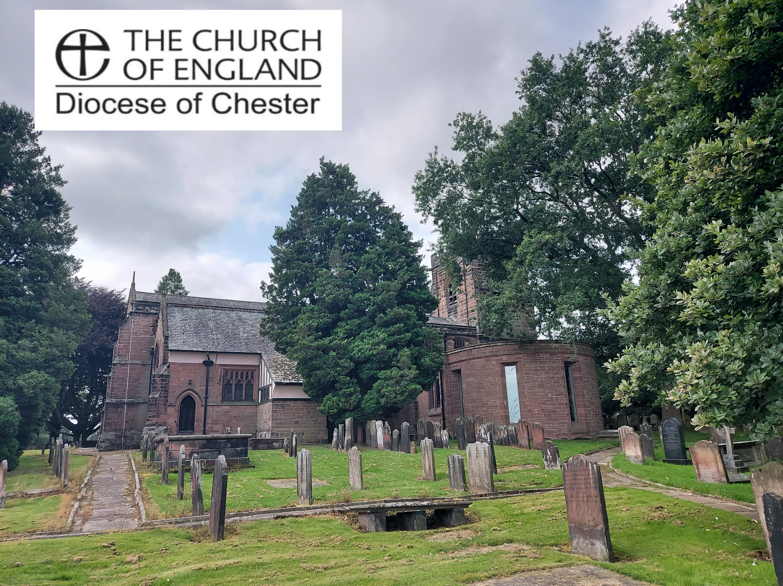

Parish Profile 2024
We are looking to appoint a prayerful and faith-led priest-in-charge, who will continue to nurture our existing church family whilst helping us to reach out to the community and encourage discipleship through example, teaching and prayer.
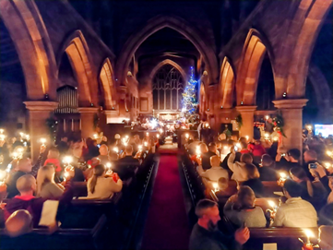
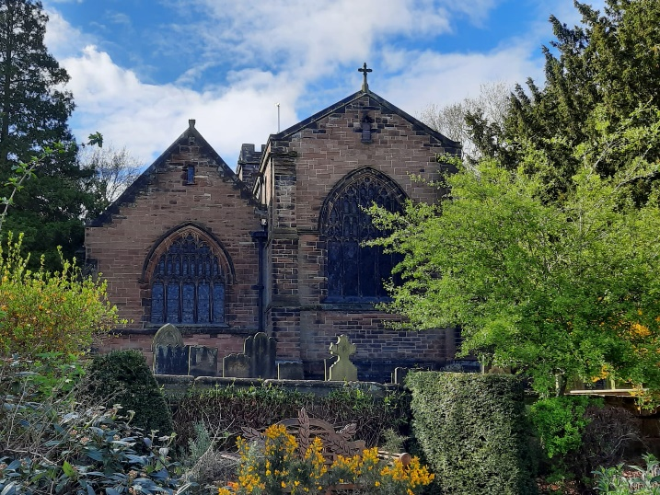

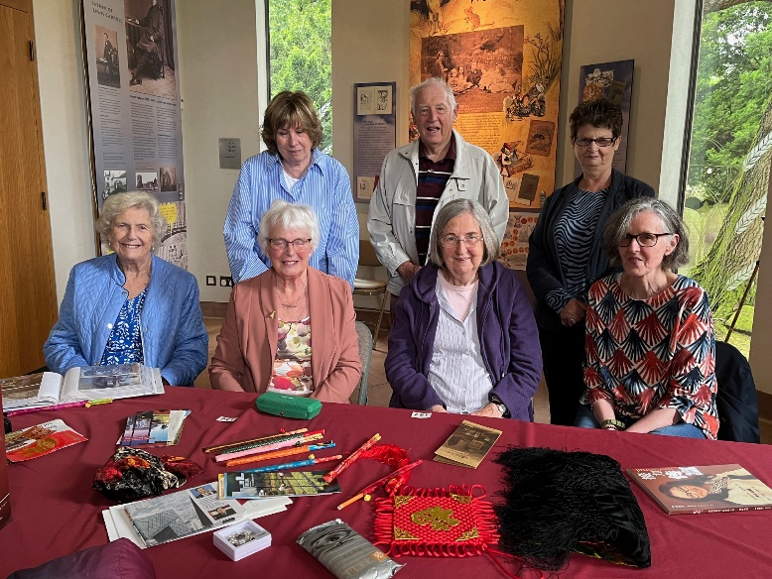
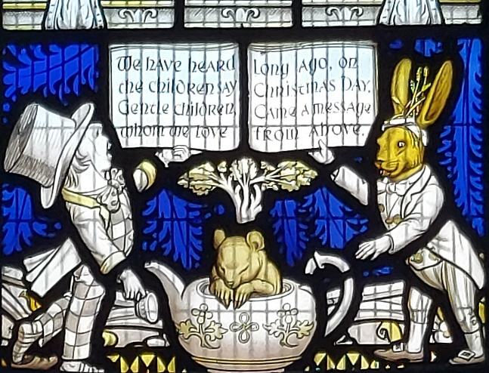
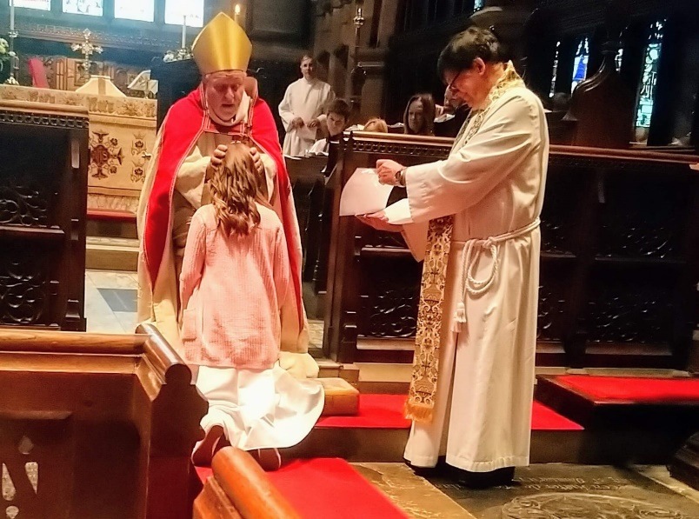
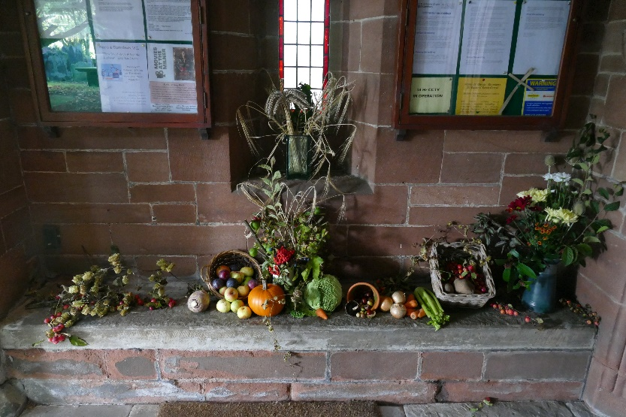
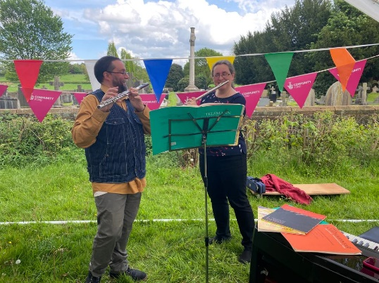
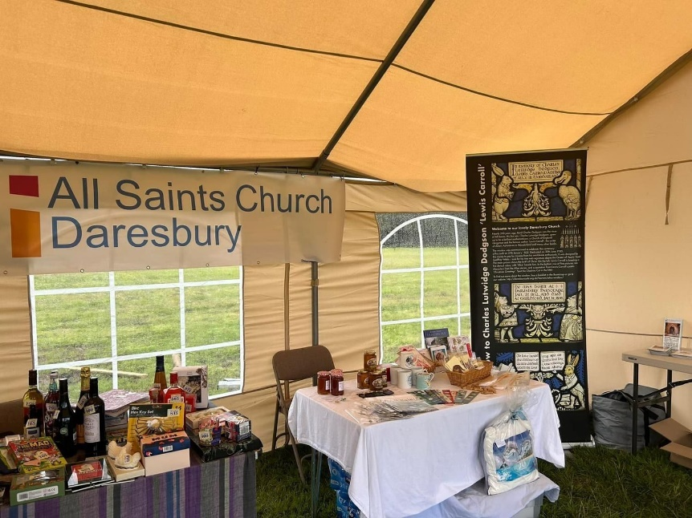
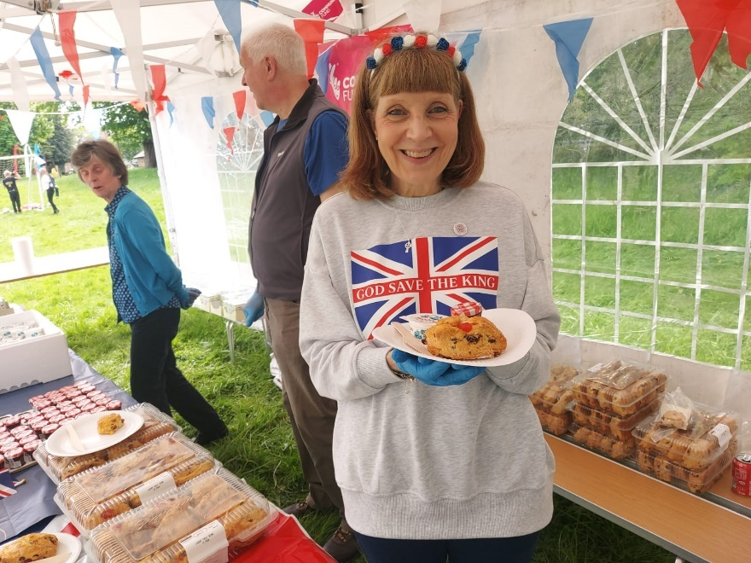
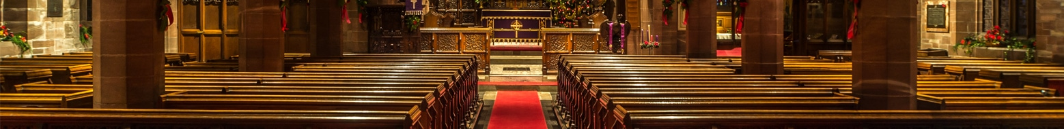

We are a rural church, proud of our history and traditions, and yet very much engaged with contemporary life. We pride ourselves on the quality of our welcome, worship and music. We endeavour to be an inclusive Christian community serving four villages and a new housing development in north Cheshire.

Our Ethos
We strive to be an inclusive and outward looking Christian community embodying the life of Christ and bound together by the love of God and love for each other, welcoming everyone who wants to learn about and be involved in the Christian journey of faith.

Welcome to All Saints’

Contents
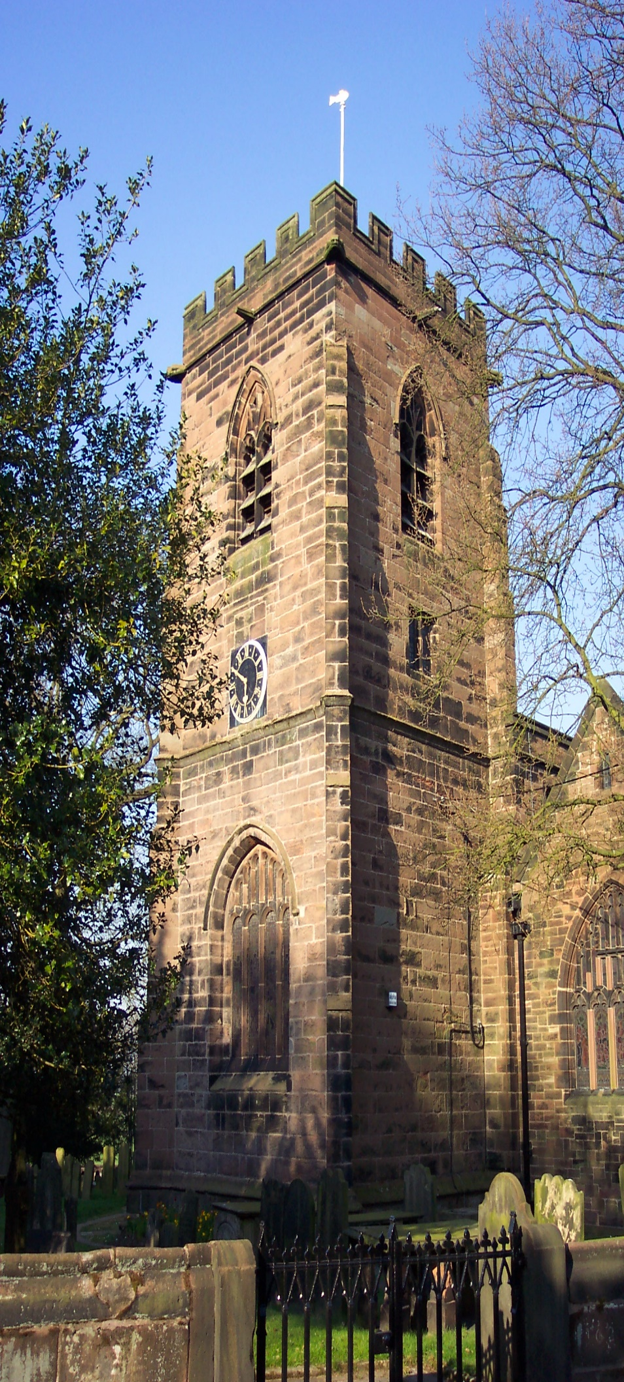
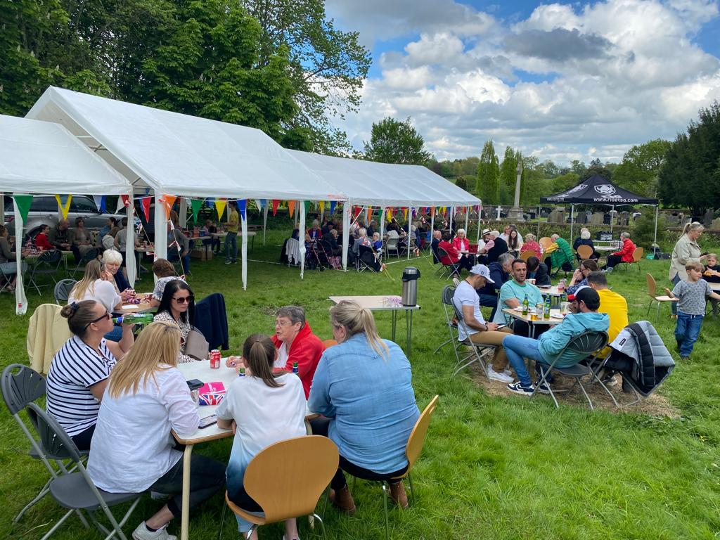
01. Contact Details 5
02. Our Invitation 6
03. What We Can Offer You 7
04. The New Vicarage 8
05. Future Vision 9
06. The Parish 10
07. Church and Community 14
08. Worship 16
09. Finance 19
10. History 21

Celebrating the King’s Coronation

2. Our Invitation

Contact Details
Email: office@daresburycofe.org.uk
Website: https://daresburycofe.org.uk
Address: All Saints’ Church, Daresbury
Daresbury Lane
Daresbury
Cheshire
WA4 4AE
Office: All Saints’ Church Office
Daresbury Village Hall
Chester Road
Daresbury
Cheshire
WA4 4AE
Vicarage: 4, Crooked Acre Lane
Daresbury Garden Village
Daresbury
Cheshire
WA4 4GL

Churchwardens
Name: Andrew Wang
Mobile: 07905 122372
Email: warden1@daresburycofe.org.uk
Name: Ian McIntyre
Mobile: 07904 664695
Email: warden2@daresburycofe.org.uk

We are looking to appoint a prayerful and faith-led priest-in-charge, to be shared with the parish of St. John’s, Walton. He or she will continue to nurture our church family, help us to reach out to the community and encourage us through example.

He or she will need to be:
● an effective, motivating and collaborative team leader;
● able to create a sense of community within the church;
● capable of introducing new ways of sharing our faith;
● be willing to explore new forms of worship and be open to new ideas;
● an effective communicator both inside and outside the church;
● able to reach out to the young inside and outside the church;
● able to encourage the congregation to live out their faith in daily life, Monday to Saturday, not just on a Sunday;
● able to foster a good safeguarding policy in the church;
● willing to develop mission and evangelism within the church;
● able to reach out and liaise with people and groups in the wider community;
● friendly, intuitive and an empathetic listener with good communication skills;
● able to develop and use spiritual gifts within the church;
● an energetic, challenging and inclusive teacher with a clear vision.

3. What We Can Offer You

The chance to work in a unique but rewarding idyllic, rural church with strong Lewis Carroll connections, strong support teams in mission and logistics along with a brand-new family vicarage.

We can offer you:
● a Ministry Team including one Reader, one Reader Emeritus and one in training (each with differing styles of preaching the Gospel);
● a Director of Music with robed choir;
● a Pastoral Worker;
● a caring, supportive, diverse and surprisingly active multicultural congregation, including many Farsi speakers;
● a new vicarage within the parish;
● the attractive opportunity to inherit The ‘Alice in Wonderland’ Church;
● we recognise that the post is going from full-time to part-time, but we have dedicated Facilities, Finance and Events teams;
● a paid-for accountant;
● the chance to work in a unique but rewarding rural/suburban parish, with the M56, good rail links and Daresbury Park (an internationally recognised scientific research facility) on its doorstep.

The Post
The post is full-time, to be shared with St. John’s Church, Walton. For Daresbury, it is a great opportunity to continue recent work in building relationships with local schools and groups as well as the expanding development of Sandymoor with its large numbers of young families.

4. The New Vicarage
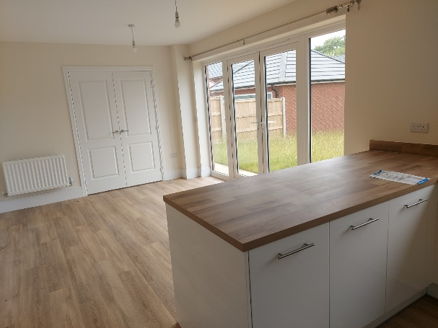

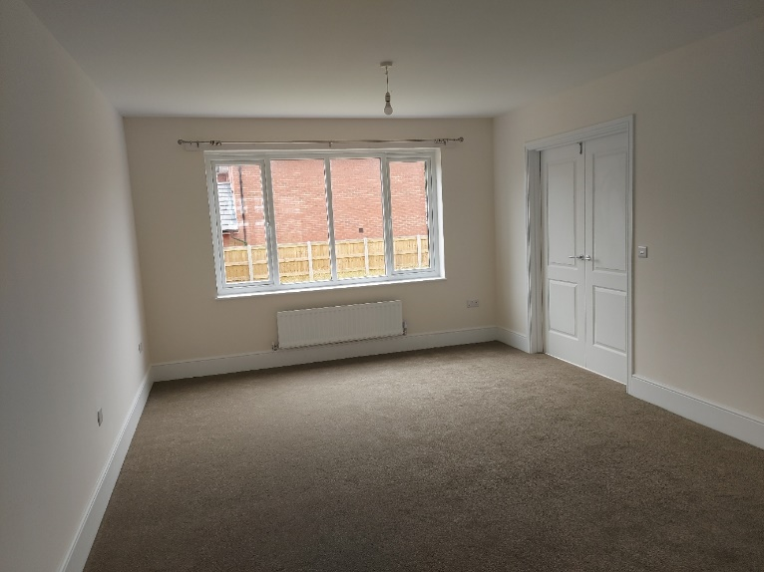
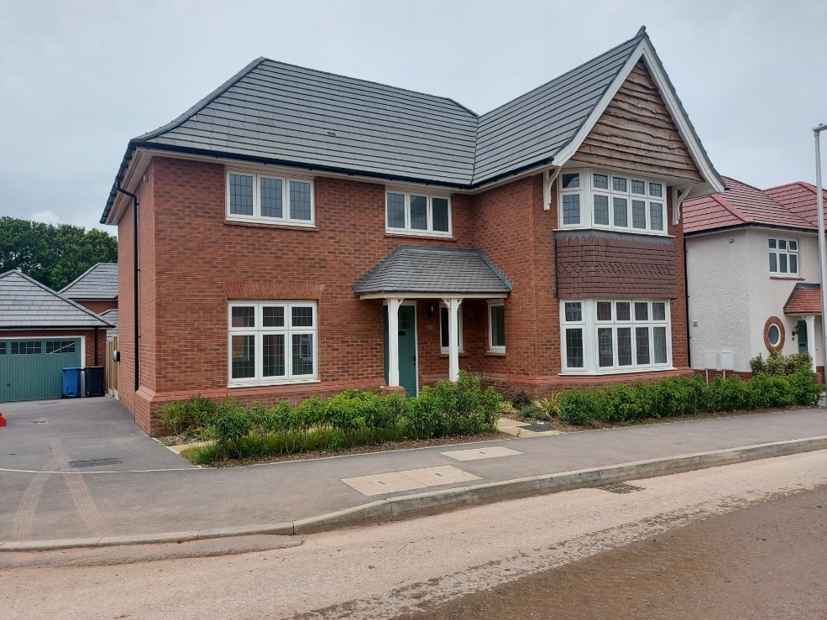
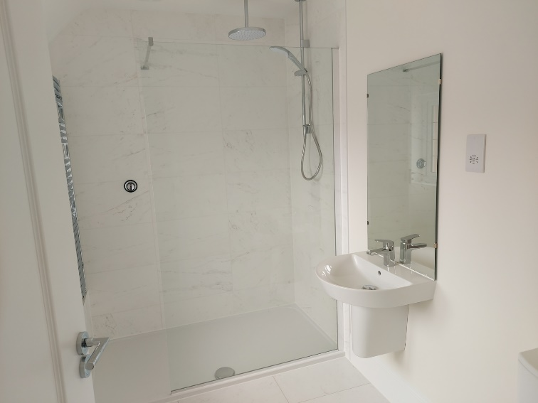
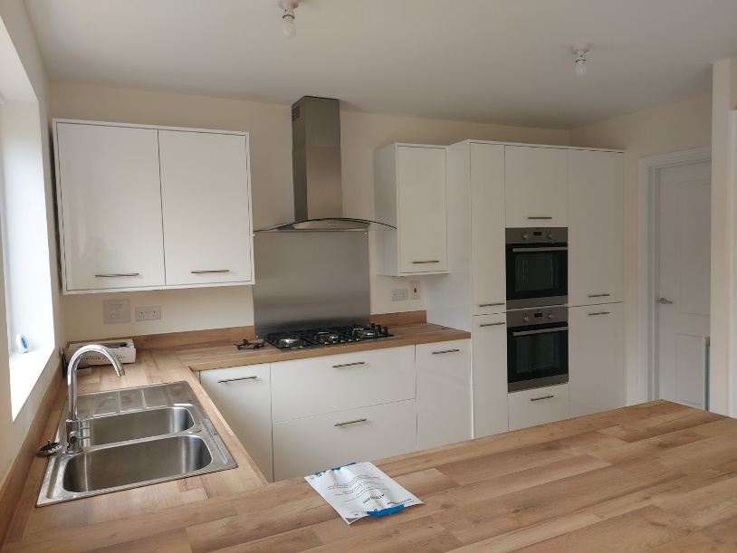
5. Future Vision
The vicarage is a new build on the Daresbury Garden Village development, approximately half-way between the church and Church House which has the diocesan offices. There are four large bedrooms, two en-suite, two reception rooms, a downstairs toilet and a large kitchen and dining room.
We recognise that sharing a priest with Walton will be a new arrangement for us and we will need to adjust our expectations for the future.

Young people
- To encourage young people into church
- To establish a young person’s church
- To develop further a style of worship to encourage young people

Communities
- To grow the congregation by reaching out to different communities
- To develop links with recent housing developments in the parish
- To create a church that is open to different groups and cultures

Mission
- To encourage a greater proportion of the congregation to be involved in mission and evangelism
- To grow and deepen the faith of the congregation

New worshippers
- To create a safe and welcoming environment to encourage new members of the congregation to return

New vicar
- For church members to work alongside and to actively support the new minster to develop their own style
- To help the new minister to foster a collaborative ministry in church

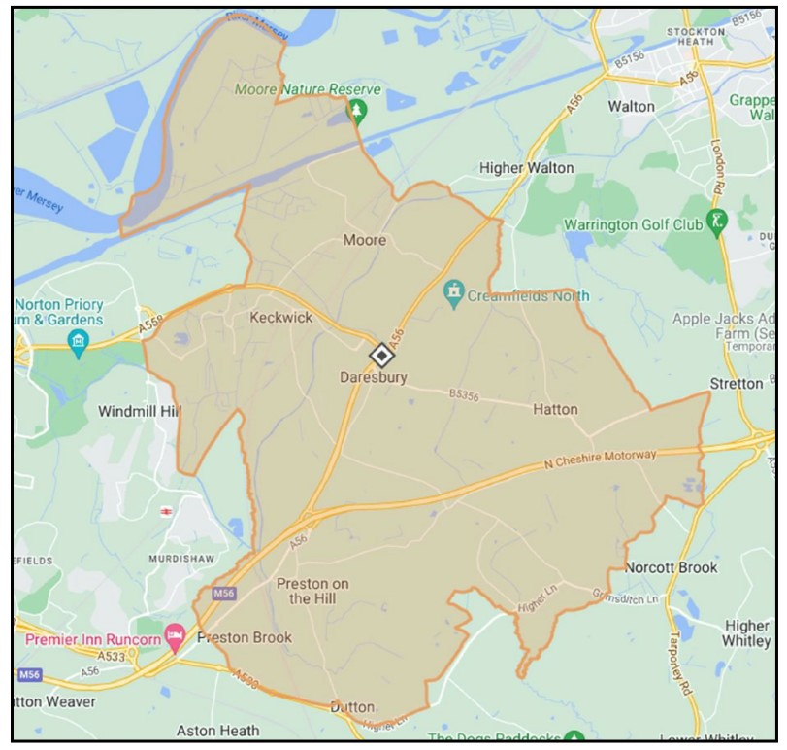
6. The Parish
The parish includes the villages of Daresbury, Preston-on-the-Hill, Preston Brook, Hatton, Moore and the Sandymoor development. The Creamfields North Festival, held each August Bank Holiday, takes place in fields adjacent to the church.

Parish and Visitors
If you were to ask our church community what All Saints’ means to them, you will receive a wide variety of answers. For some, it is their family’s history and is deeply embedded in their lives. Some describe it as their spiritual home, even though they live far away, and some remember the welcome they received when they first came to a service and felt at home in their new church family. Others will say it’s the worship, the teaching, the music, the spiritual feeling. For most it is a combination of things, and a sense of belonging.
In March 2020, an entry written just before lockdown, reads, ‘Thank you. We stopped on our walk and found solace, and asked God to keep us safe, along with our loved ones and everyone in the world during coronavirus.’

To the local community and for those arriving from further afield, the church offers a welcome, a place to pray or light a candle, to feel calm, and is a haven from life’s busyness for a while. Visitors write about it as uplifting, peaceful, spirit-filled, a place to pray and feel God’s love, a place where they feel accepted.

The Parish of Daresbury
The parish of Daresbury lies within north Cheshire, between Runcorn and Warrington, mostly in the Borough of Halton, although Hatton is part of Warrington Unitary Authority. It could be described as semi-rural, developing and scattered, with a good many listed buildings and features. Each of the individual villages which make up the parish have their own parish councils.

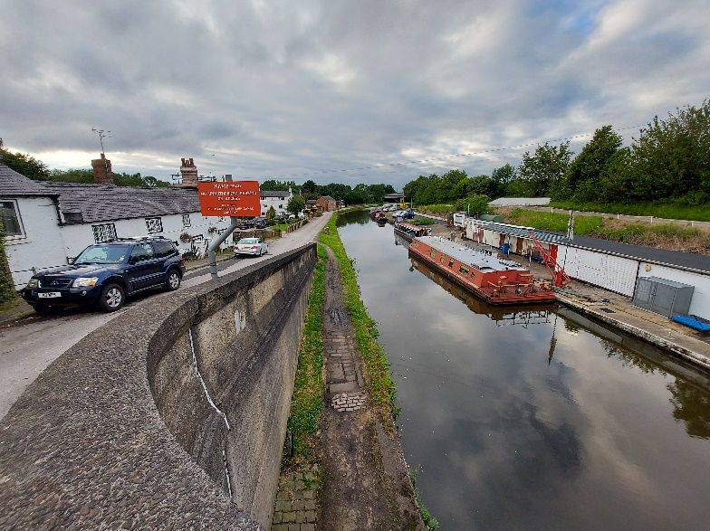
Preston Brook
Preston Brook has some older buildings along the canal and new housing close to the Spar shop and Tannery Farm. The Spar shop has a post office.
The village hall dates from the 1970s and is well used by local groups, including a nursery. Preston-on-the–Hill was the original township and has several old farmhouses, cottages and houses lining the village street. It once had two Methodist chapels and a mission hall.
The Bridgewater Canal at Preston Brook

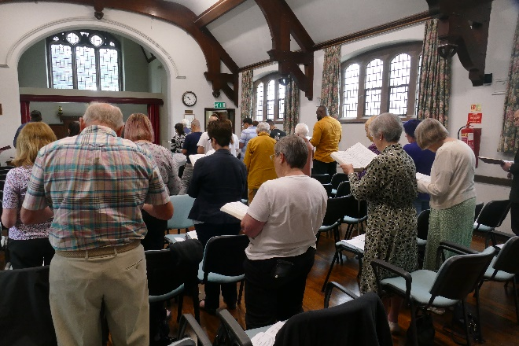
Moore
Moore has some fine old farm buildings, cottages and houses, and Moore Hall. There is a pub, village shop with post office and the Milner Institute. This serves as a village hall and hosts groups including Moore and Daresbury WI. A communion service is held there on a Thursday morning, and on ‘Milner Sunday’ in July, the whole congregation moves to the Milner for the 10.30 service.
Milner Sunday service

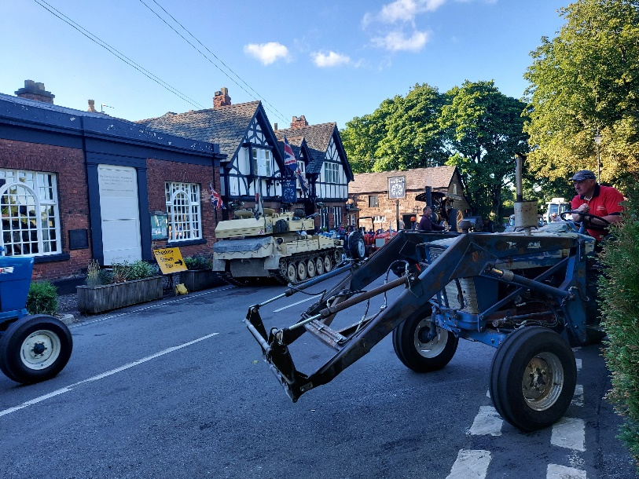
Daresbury
Daresbury has a mixture of modernised farm buildings and cottages as well as new housing. It has a pub/restaurant, incorporating the Sessions House, and a village hall. There are new housing developments in the Daresbury area, including Daresbury Garden Village, where the vicarage is.
Ring o’ Bells and Session House during the Cheshire Steam Fair

Hatton
The village has a mixture of cottages, farmhouses and recent houses. It had two Methodist chapels. There is a pre-school and a pub.

Sandymoor
Sandymoor is an area of new housing within the parish. It has a secondary school, a community centre and various shops.

Education
There is no church school in the parish, although Moore and Daresbury both have primary schools. The present incumbent has built closer relationships with the schools. They make educational visits and sometimes hold assemblies and Christmas services in church. In 2012, Sandymoor Free School for secondary education was established, and it became part of the Ormiston Academy Trust in 2019.

Farming and Industry
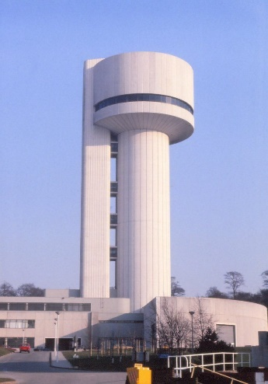
There are still some working farms within the parish, although many of the old farmhouses and outbuildings have been developed for housing.
Agricultural businesses now work alongside science and technology firms, in particular Daresbury Laboratory and the Sci-Tech campus which continues to grow around it. We host the lab’s Christmas Carol Service and one year the church and centre were also the venue for the closing session to an international conference which they were hosting.
Daresbury Laboratory tower when new
Other areas of employment in the parish include Daresbury Park, where Church House and the Daresbury Park Hotel are located. Part of the Whitehouse Industrial Estate is in Preston Brook, where several logistics companies are based.

Transport
The parish has good transport links. The M56 provides access to the M6, Manchester, Chester and North Wales. Junction 11 lies between Daresbury and Preston Brook. Railway links are good. The nearest railway stations are Warrington, Runcorn East and Runcorn.
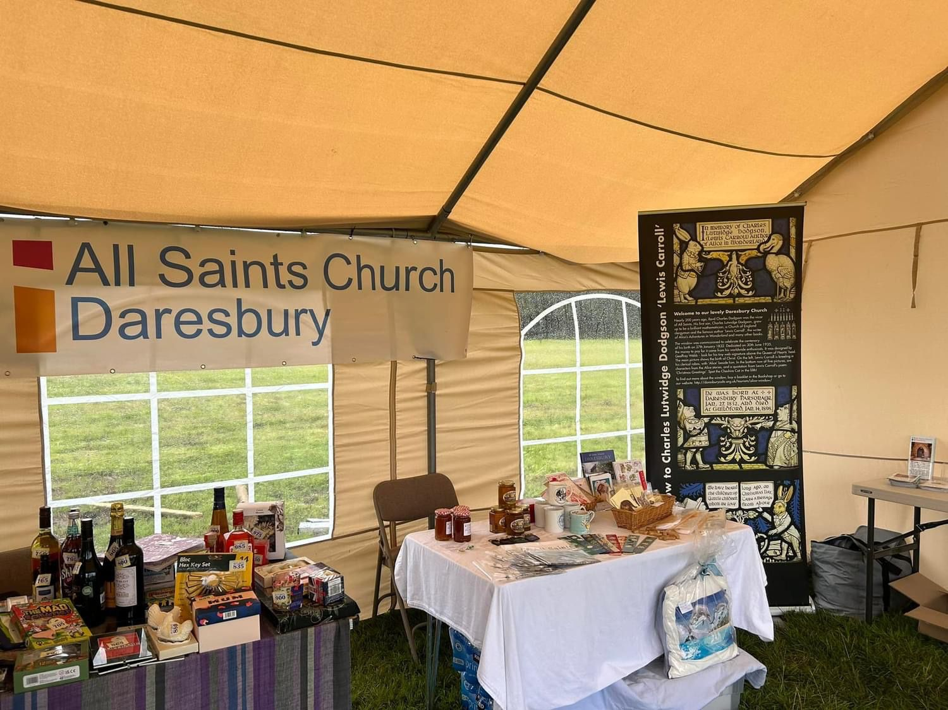

Part of the church marquee at Sandymoor Fair

7. Church and Community Groups

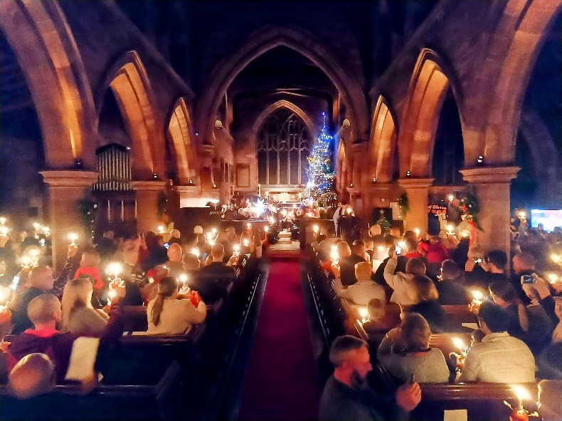
The Church
The church is arranged in a traditional layout, with chancel, nave, north and south aisles and vestries. Victorian pews provide seating, and chairs and benches are also brought in for large congregations on Remembrance Sunday and for Christmas.
A Christingle Service
The Daniell Chapel is on the south side of the chancel and is enclosed. Chairs provide seating here, and it is where quiet, reflective services are held. The candle stand is here, and the chapel is used for private prayer.
There is a shop, which stocks church and Lewis Carroll souvenirs, books and local produce.

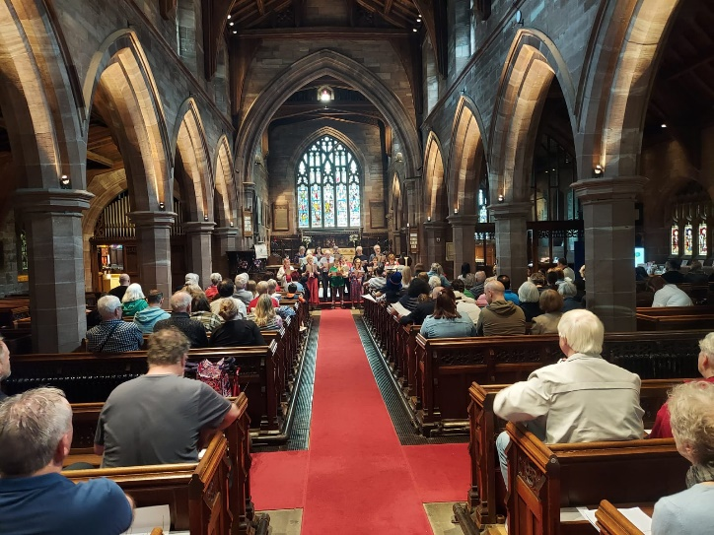
Music
Music of all types is an important part of our worship and parish life. Claire Longstaff, our Musical Director, has been in her post since 2009. Claire is supported by our deputy musical director, Gyopar Pavai, and our organist Hugh Wallace. We have a robed choir of around 16 members who sing at the 10.30 Sunday services and lead choral Evensong on the first Sunday of the month. They provide music for weddings, funerals and other special services throughout the year. Highlights of the year are the annual Nine Lessons and Carols service and Easter Praise.
Sing for the King with local schools and choirs
The organ is kept in good order. It underwent major work a few years ago after the church mice decided to chew the bellows. An electric piano is also used to accompany worship.
The Musical Director and her team are also keen to use music to reach out to the wider community and have had great success in organising events involving local school children, the church choir and the community choir. We feel very fortunate to have such a strong, professional and talented musical team to lead our worship.

The Lewis Carroll Centre
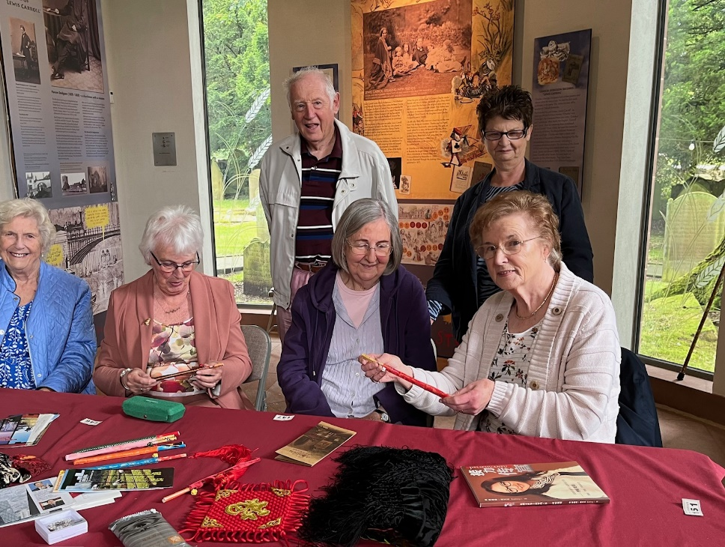
The Lewis Carroll Centre allows community and combined groups to meet. The Church Fellowship, Men’s Breakfast and Crafters Groups each hold monthly meetings here. There is a weekly social drop-in with tea, chat, crafts and games. It is where occasional coffee mornings and the Lent lunches take place.
The Church Fellowship after a talk on China
A local history group, the Daresbury District Heritage Group, which grew out of a WW1 project to research the names on the war memorial, hold their meetings in the centre, and it is where the community choir take refreshments after singing in the chapel on a Friday morning. Visiting school groups do activities here, including workshops covering the Lewis Carroll link and the church history. It is used as a Polling Station for elections, as an exhibitions space for Remembrance week and during Heritage Open Days, as well as for craft sales and other events.

Ecumenical Relationships
The church is a member of Love Runcorn and Bridgewater Churches Together. Our outreach work includes links to Runcorn and District Food Bank and Trinity Safe Space (a group helping asylum seekers in Runcorn).
Our relationship with other churches includes links with Roman Catholic and Methodist churches as well as links to Muslim groups. We work with these churches and groups on an ad hoc basis. We have links to Christian Aid during Christian Aid Week and in the past via Christmas Concerts. USPG collections are made during Lent. We also support British Legion and Combat Stress, Children’s Society via the Christingle Service, and the Toilet Twinning scheme.

8. Worship

Sundays
All Saints’ Church enjoys a high standard of worship. All Communion services are sung, apart from the 2nd Sunday evening service. Average 10:30 attendance is currently 57. The services are live-streamed on Facebook. The Gospel is read out in both Farsi and English. Sometimes the sermon is translated into Farsi. Currently our Sunday services are:

Sunday | 08:30 | 10:30 | 6:30
1st |  | Holy Communion | Choral Evensong
2nd | Storytime (0-8 yrs) | Morning Prayer | Holy Communion
3rd |  | Holy Communion
4th |  | Holy Communion | Celtic Service
5th |  | Holy Communion

Other Services
Service | 2018 | 2019 | 2020 | 2021 | 2022 | 2023 | 2024
Baptism 1 | 2 | 3 | 0 | 0 | 0 | 2 | 0
Baptism 2 | 33 | 31 | 10 | 25 | 56 | 53 | 23
Confirmations | 8 | 9 | 0 | 0 | 0 | 0 | 1
Weddings | 11 | 10 | 5 | 7 | 15 | 5 | 2
Funerals | 17 | 12 | 13 | 19 | 18 | 16 | 9
Ashes | 16 | 4 | 7 | 9 | 18 | 15 | 4
Burials | 1 | 1 | 0 | 0 | 6 | 0 | 0
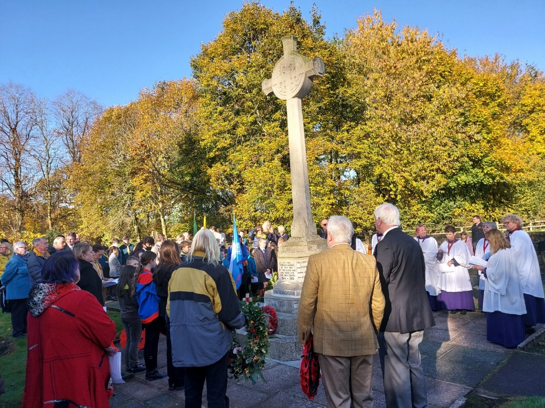
Baptism 1: Baptisms in public worship
Baptism 2: Baptisms in private worship
Ashes: Burial of ashes
Burials: Burial without a funeral service
Figures for 2024 complete to 21st July. Several more weddings are booked for the rest of the year.
Remembrance Sunday at the cenotaph with local schools and uniformed organisations

Other Forms of Fellowship
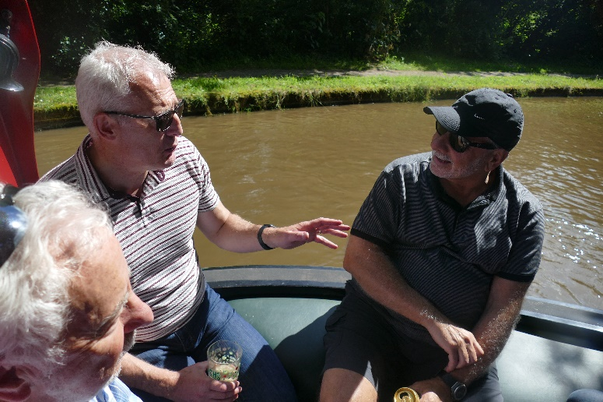
The monthly Men’s Breakfast presents an opportunity for discussion and fellowship. It is not limited to church members.
The weekly Community Drop-in is open to everyone. It’s a chance to meet each other in the Lewis Carroll Centre in a relaxed environment over a variety of games with tea and cake.
A Men’s Breakfast boat trip
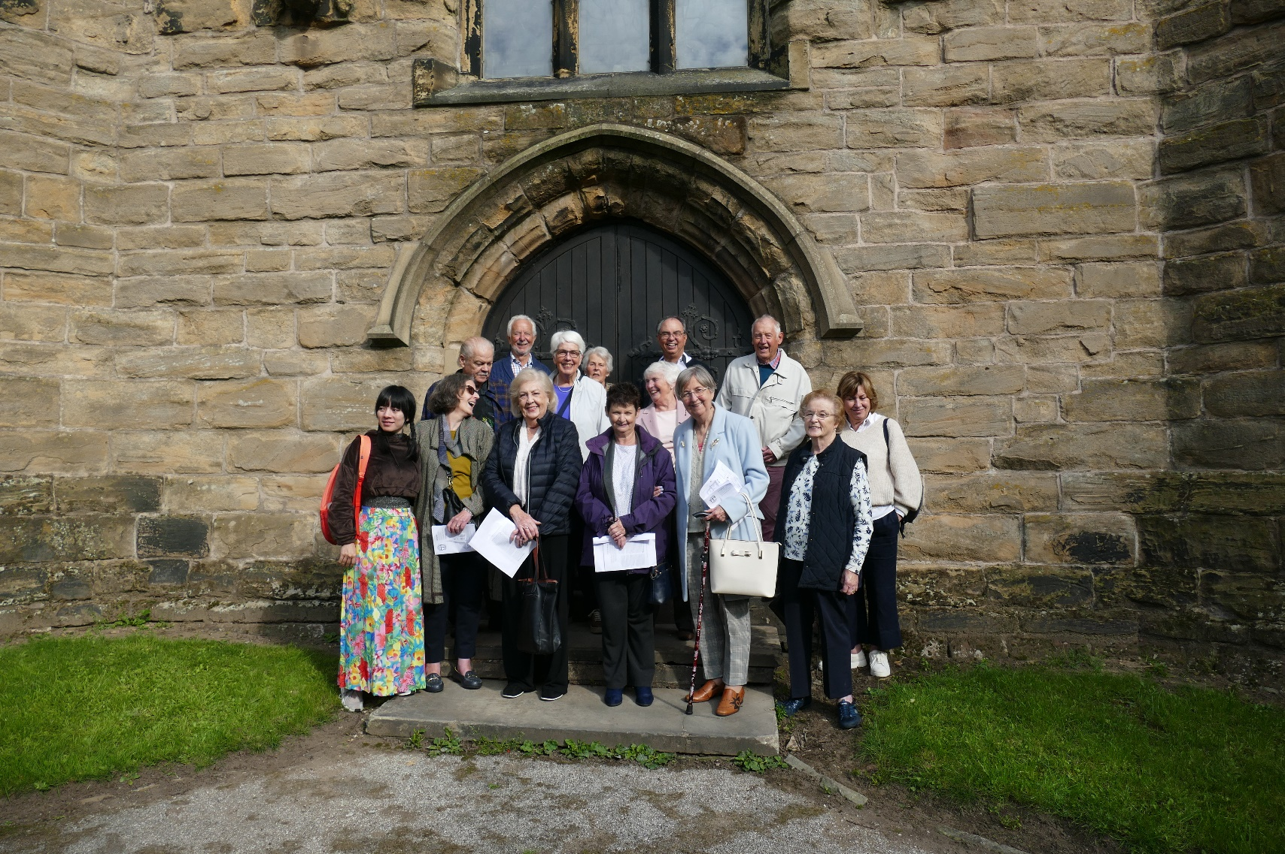
Our Church Fellowship meets once a month. It is also open to everyone, not just members of the church. There are occasional talks on a variety of subjects. In the summer the fellowship might go on one or more trips.
The Crafters Group meet monthly and is open to all. They share their respective skills and know-how over tea and coffee. Their annual successful Craft Fair raises funds for the church.
The Church Fellowship on a summer visit
Daresbury Community Choir meet weekly in the Daniell Chapel. They sing in a variety of styles. The number of members is growing and they enjoy taking part in choir events.
The Bell Ringers meet once a week. The church has eight bells and the group regularly ring on a Sunday morning and special occasions. The bells are also rung by visiting groups.
A Farsi Bible Study group, with asylum seekers from a local hotel, meets in the Lewis Carroll Centre on Sunday afternoon after a communal lunch.
The church has an enthusiastic group of volunteers who do the church cleaning, guiding on Sunday afternoons, staffing the shop and flower arranging.
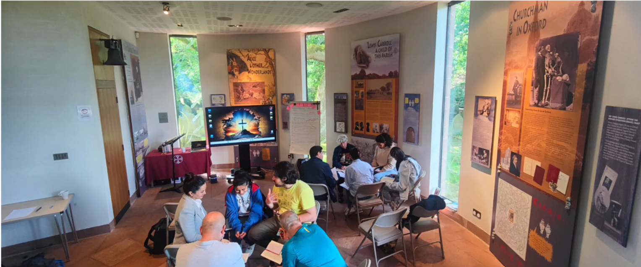
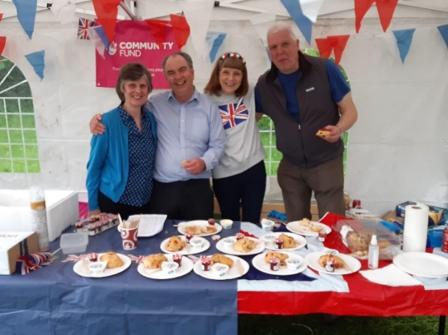

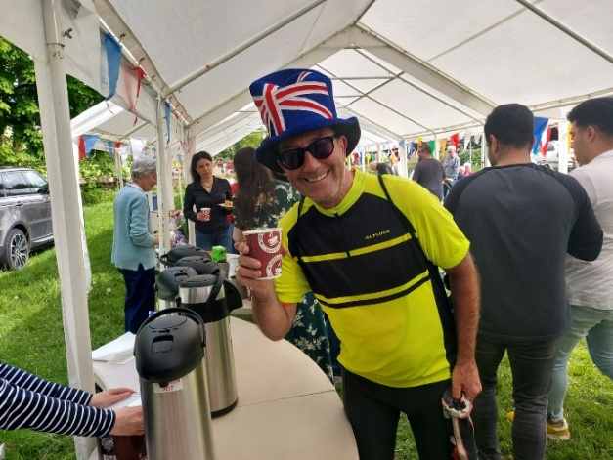
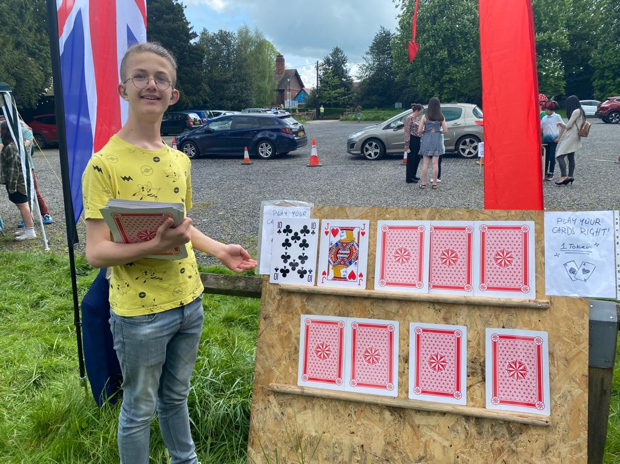

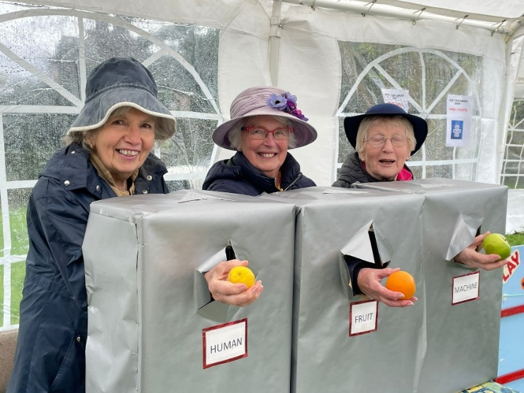

9. Finance
Cream teas, Farsi bible study group, a patriotic cuppa, Play Your Cards Right and a human fruit machine

Introduction
Although All Saints’ Church faces financial challenges, we are committed, through careful management of resources and proactive fund raising, to ensure our church not only remains viable but thrives financially.
Parish financial matters are managed by the Treasurer, supported by the Gift Aid Administrator and the Finance Team. They are further supported by a paid professional bookkeeper and an active and enthusiastic Events Committee.

Our Present Position
While our 2024 budget is again forecasting a deficit, we are working to address this shortfall by raising awareness across the parish and through imaginative fund raising. In particular we are keen to engage with parishioners living in the newly established housing estates within the Parish.
Our income and expenditure for previous years is shown below:

 | 2021 | 2022 | 2023
Income | £85,680 | £119,169 | £117,522
Expenditure | £90,403 | £109,340 | £138,653
CBF Investment Fund | £60,032 | £52,997 | £58,026

Our funds total at the end of 2023 was £96,802.

Please see our financial statements for further details.
Financial statements at the Charity Commission

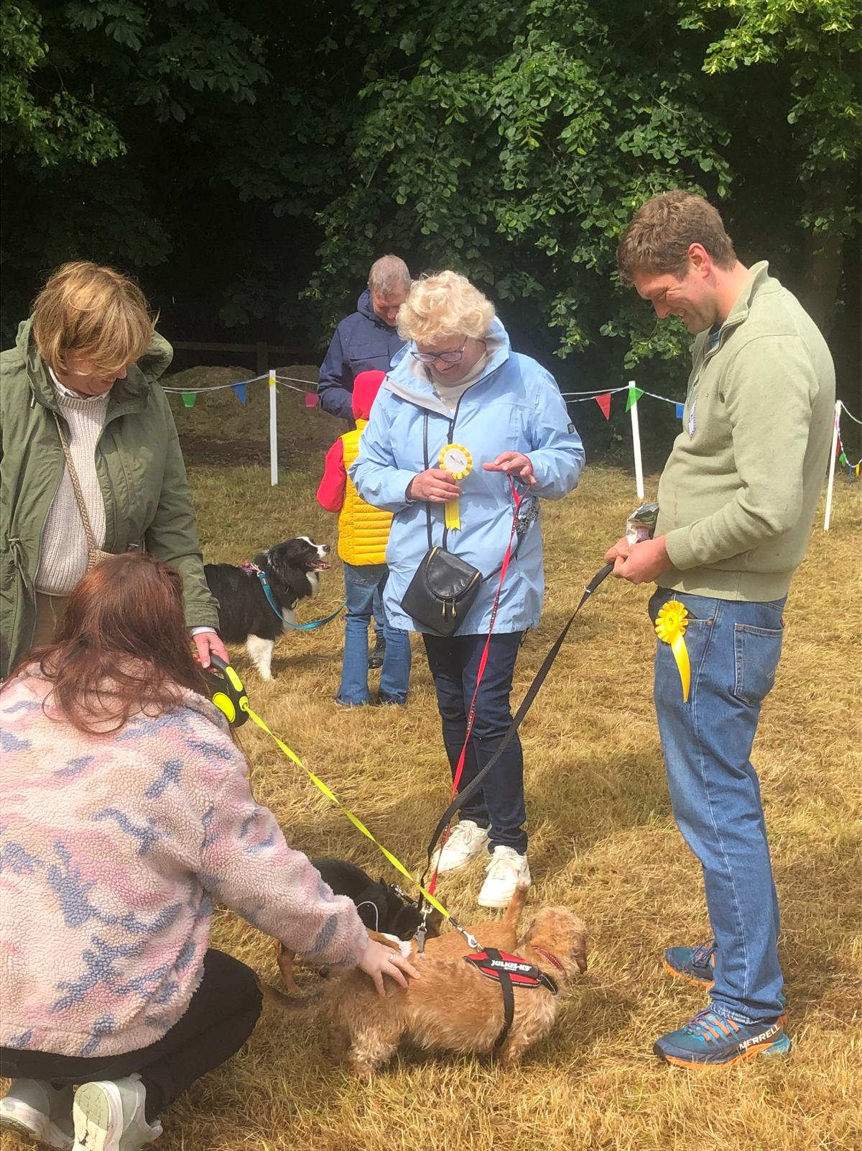
Fund Raising
A tangle of dogs at a church garden fete
The Events Committee have put together a full programme of events for the year. These include, quiz evenings, concerts, other social evenings, the annual church fete and the Christmas Lights switch on event.
We have also recently introduced ‘The Alice Lottery’ aimed at raising funds for the maintenance and preservation of the church building and grounds. It is early days, but we are optimistic that this will prove an excellent source of regular funds.
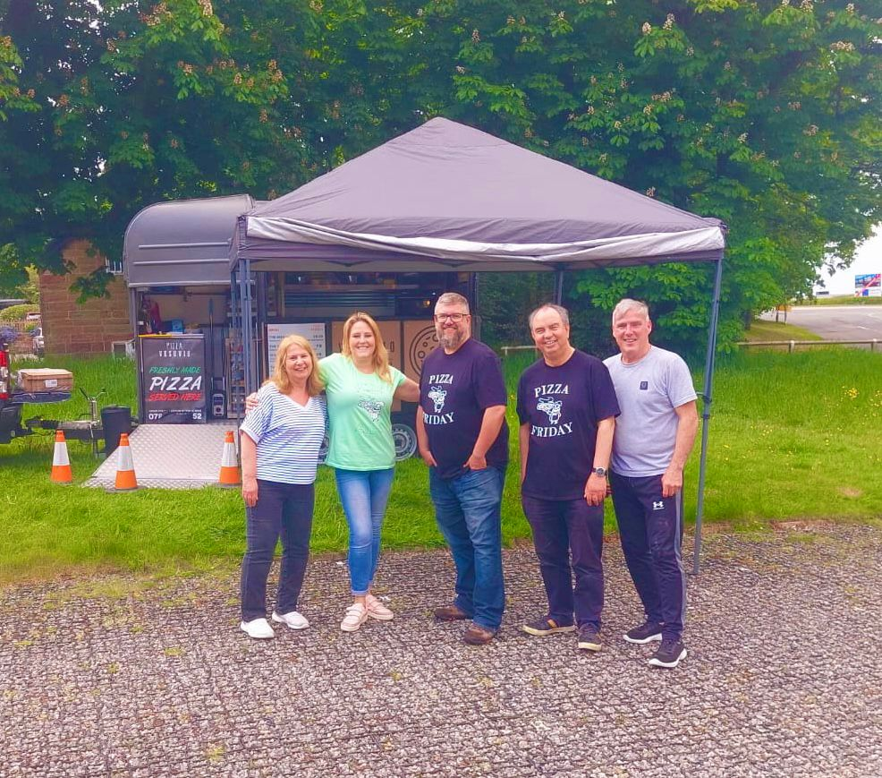
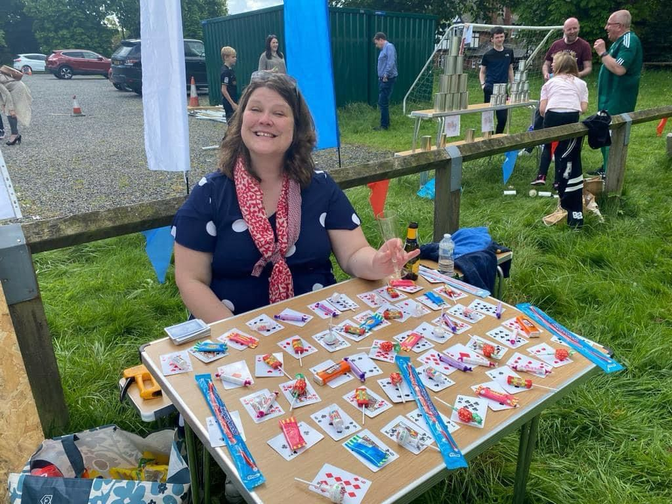
Sweet Tombola
Pizza Friday

10. History
Walk through the door of All Saints’ and you cannot fail to feel a sense of history. God has been worshipped in this community for at least 850 years. This is still a place of celebration and community life. The Christian faith gives order and purpose and shape to our lives. It enables us to appreciate the beauty of God’s creation. Our faith links the present to the past and keeps us looking to the future. That way we are truly the community of all the saints.

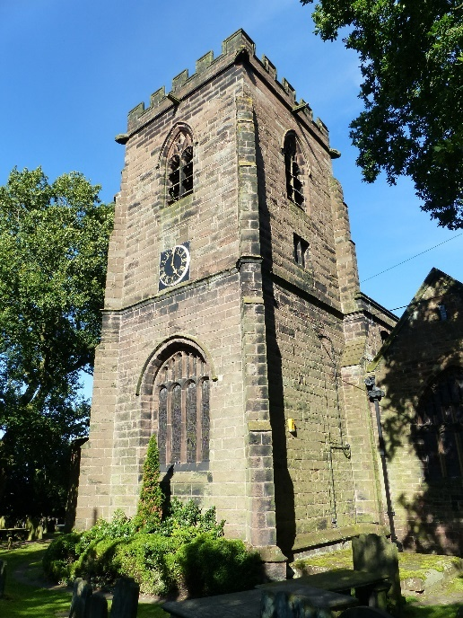
Our Beginnings
Daresbury church was founded in the 12th century, as a daughter house to nearby Norton Priory. The first church erected at that time was probably a simple wooden building, plastered and painted white. However in 1536, as a result of King Henry VIII’s dissolution of the monasteries, Norton Priory’s property was redistributed, and Daresbury came into the hands of Christ Church College, Oxford, which gained the right to collect taxes and appoint the ‘perpetual curate’ to the living. Shortly afterwards, a stone church was built where All Saints’ stands today. The tower is the only part of that church which remains, and bears the date 1550 in worn numbers set high on one wall.
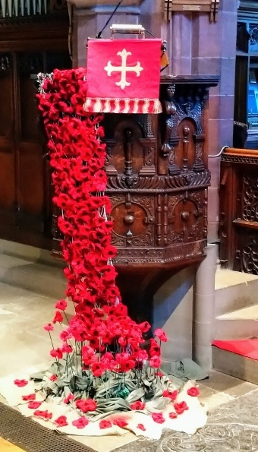
By the middle of the 19th century, after three hundred years of repairs and alterations, the main body of the church needed restoration, and the Lancaster architects, Paley and Austen, were given the commission. The building they designed, in the Perpendicular Gothic style, was completed in 1872, just over 150 years ago, and is now a Grade 2* listed building.

Church Features
The church contains many features from its past including a Jacobean pulpit, wonderfully carved with elaborate mythological figures. Set on the east wall, are the panels of the reconfigured carved screen containing the face of a ‘Green Man’, the Daresbury acrostic board of bell ringers’ rules is fixed in the ringer’s chamber, and
Victorian stained glass by Hardman of Birmingham and Clayton and Bell fills the windows. The stained glass in the Daniell chapel is by 20th century artists Geoffrey Webb and Trina Cox. We also have two fonts, an elaborate Victorian one by the south door inside, and the font of about 1600, which now stands outside, near to the south porch.

Green Policy
We are developing a green policy for both the church building and churchyard. This is in line with the Church of England’s drive towards net zero. We are looking at using energy more efficiently within the church. There are plans to look at how we can use and maintain the churchyard to encourage more wildlife.

Lewis Carroll Connections
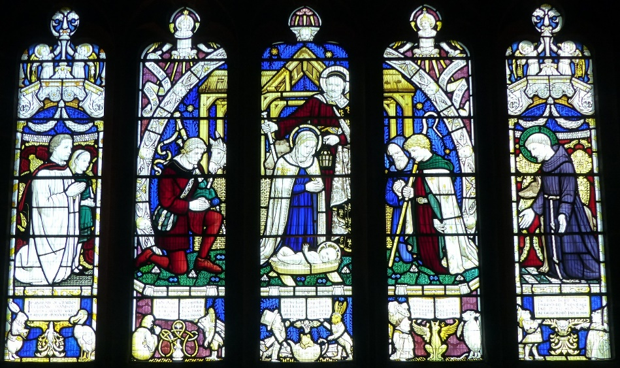
All Saints’ has the particular distinction of being associated with the celebrated author Lewis Carroll (Charles Lutwidge Dodgson) who was born in Daresbury Parsonage in 1832, when his father was perpetual curate here. The church has several features commemorating this connection, including the memorial window by Geoffrey Webb, installed to mark the centenary of his birth.
The Lewis Carroll Centre opened in 2012, and is the most recent addition to the church building. It was designed to tell visitors the story of the author’s life, from his boyhood in the quiet Cheshire countryside, to Oxford tutor, mathematician, photographer, storyteller and author. Like the church, it is open to all, every day, and we feel fortunate that this connection brings so many different people through our doors.
One visitor wrote, ‘Came to see the Lewis Carroll Centre – discovered a beautiful church.’
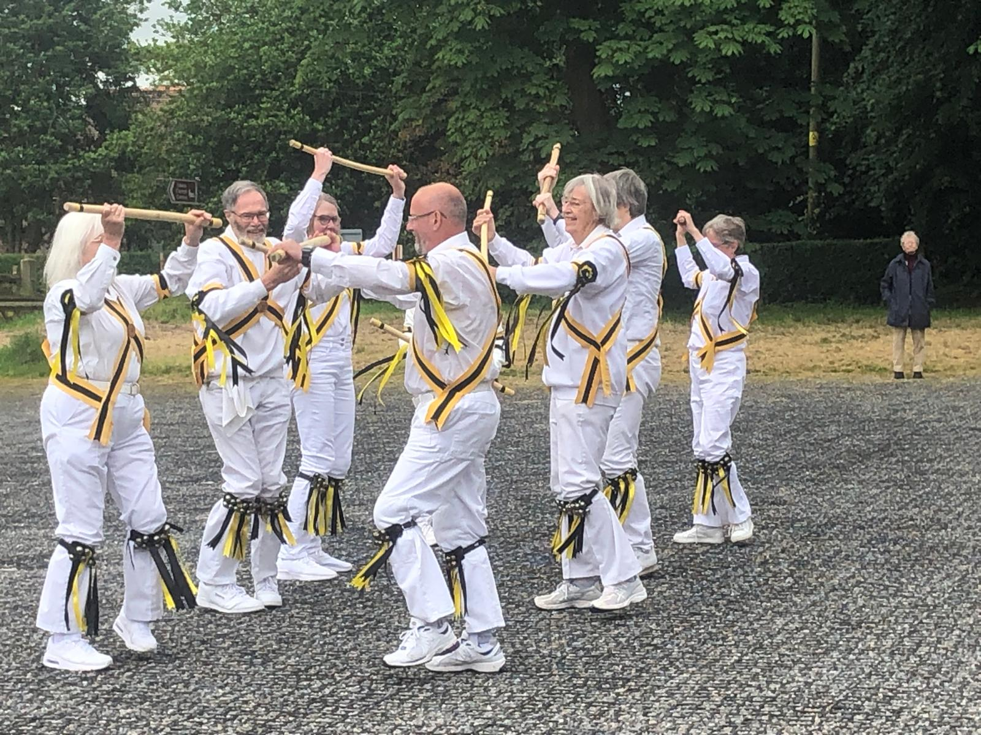
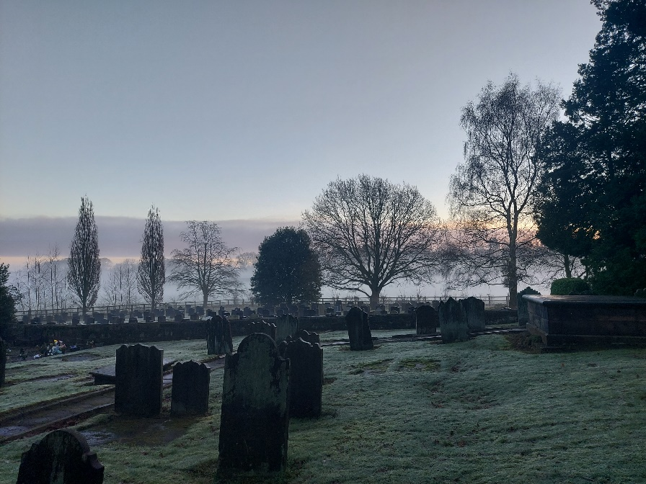

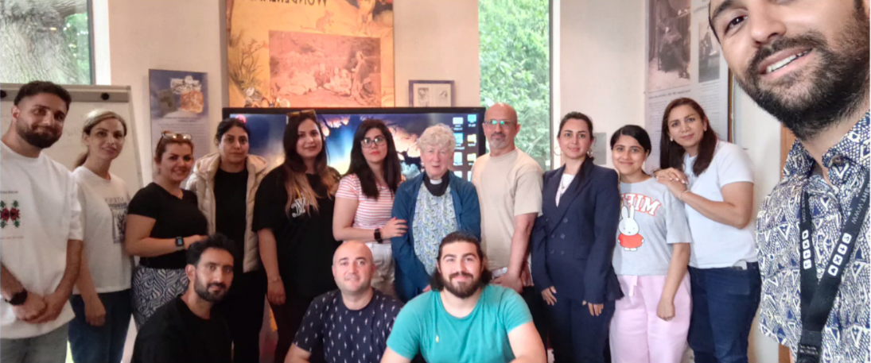
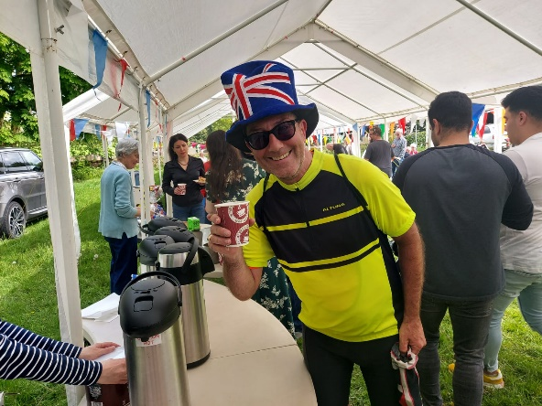

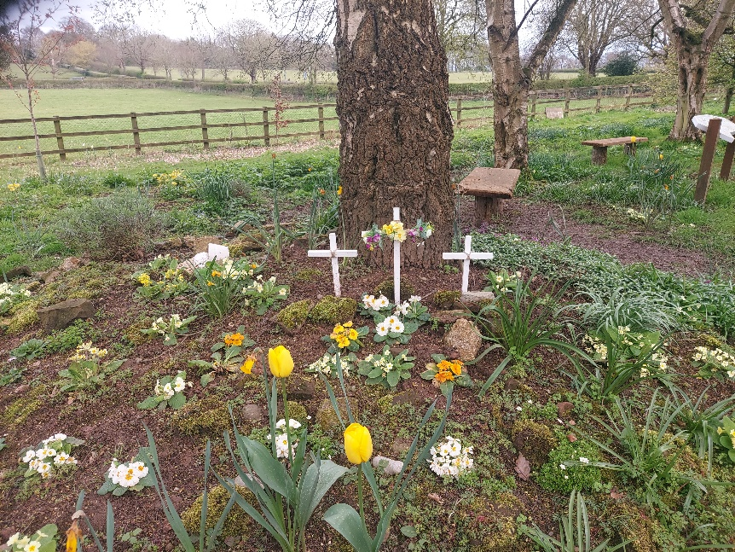
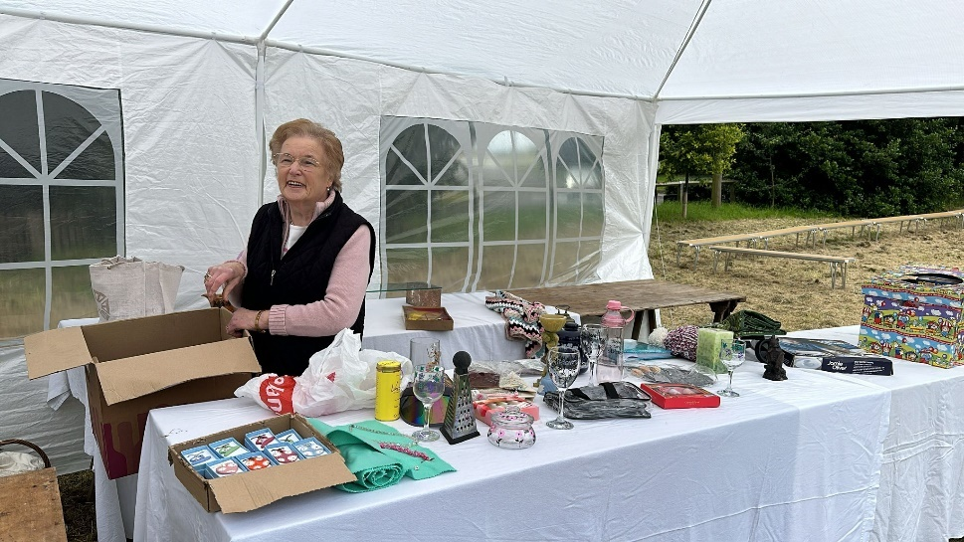
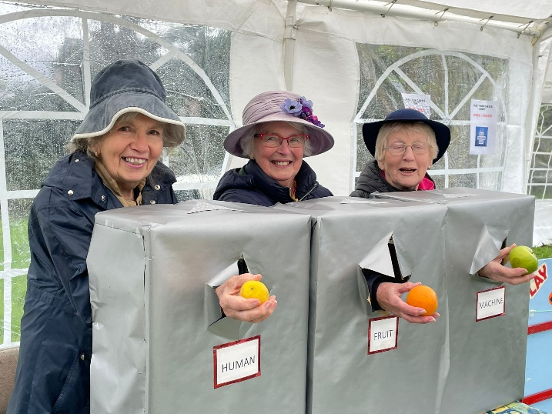

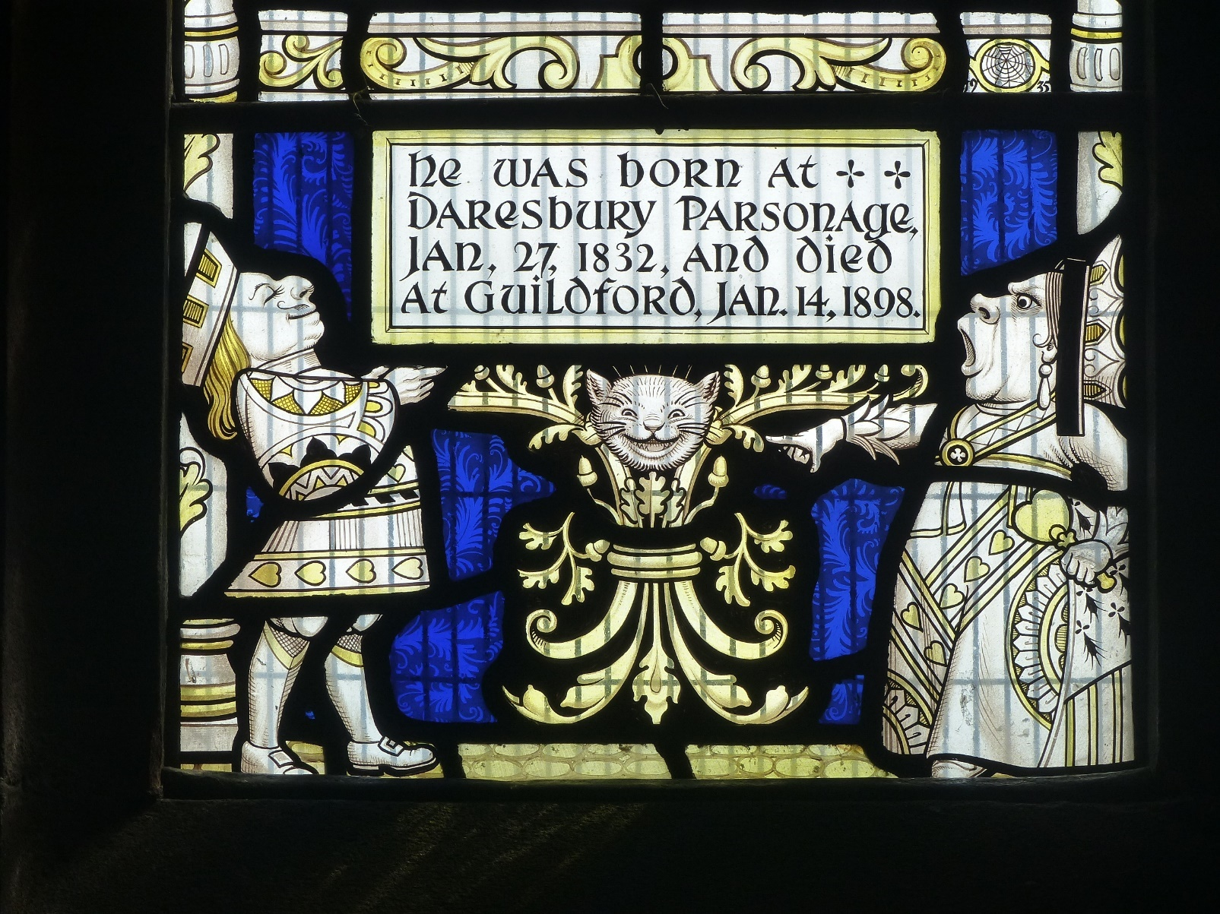

© All Saints’ Church, Daresbury, PCC. 2024.

