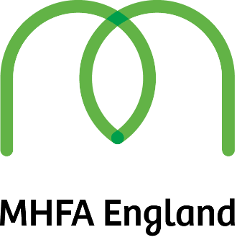

FREE MENTAL HEALTH FIRST AID COURSES FOR FAITH ORGANISATIONS

Chapter is a mental health organisation in based in West Cheshire and has 27 years’ experience of working with people with mental health issues in the area.
We have received funding to be able to offer the two-day Mental Health First Aid accredited course to Staff and volunteers in faith organisations across West Cheshire
Mental Health First Aid (MHFA) is an internationally recognised training course, which teaches people how to spot the signs and symptoms of mental ill health and provide help on a first aid basis. MHFA will not teach you to be a therapist, but just like physical first aid, it will teach you to listen, reassure and respond, even in a crisis.

The course is normally valued at £300 per head and
We have three courses available on the following dates:
14th and 15th January from 9am – 4.30 pm at the Quaker Meeting House in Chester
14th and 21st February 9am-4.30 in Ellesmere Port (Trinity Church on Whitby Road)
14th and 21st March 9am-4.30 in a Chester location TBA

The course is free but participants must agree to completing the two days
Participants will receive an accredited certificate from Mental Health First Aid England enabling them to call themselves a Mental Health First Aider
We will have to charge a £40 fee to any participant who cancels at short notice, does not turn up on the day or does not complete the course due to the value of the course

Registration Form
Name of Participant:

Dates of course required:

Faith Organisation:

Role in Faith Organisation:

Address for Certificate:

This information can also be emailed to :
sally.cerro-hughes@chapterwestcheshire.org
or by phoning the Chapter office on
01244 344409

