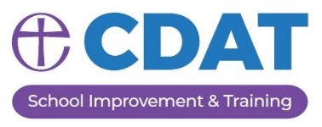
Chester Diocese School Improvement Support Package
School Support/CPD Request Form 2023-24

SCHOOL NAME:
HEADTEACHER:
To help us tailor the support you require, please detail below the support you wish to request for your three half day sessions. These can be taken as three separate half days or two can be combined to provide a full day’s support.
Focus of Support A brief title and overview of the focus of the session.
Delivery date Indicate which half term you wish the support to take place, with the option of providing three possible dates when the support could be delivered.
Staff involved Indicate which staff will be involved in the session and who will be the lead.
Delivery of support Detail what format you wish for the support to be delivered, this could be working with the HT and SLT, conducting a learning walk and/or book scrutiny, conduct a subject or aspect review, staff training /INSET,
Intended Outcomes Detail what outcomes you hope are achieved from the support.
SESSION 1
Focus of Support
Delivery date
School staff involved
Delivery of Support
Intended Outcome(s)

SESSION 2
Focus of Support
Delivery date
School staff involved
Delivery of Support
Intended Outcome(s)

SESSION 3
Focus of Support
Delivery date
School staff involved
Delivery of Support
Intended Outcome(s)

Please return completed request form to Emma Furlong:
emma.furlong@cdat.co.uk

